INTERNATIONAL ASSOCIATION OF MACHINIST’S EMPLOYEE ASSISTANCE PROGRAM JULY, 2024



HELPING HANDS

Women’s Health and Stress

(excerpts from Women’s Health, 2024)

**Stress is a reaction to a change or a challenge.** In the short term, stress can be helpful. It makes you more alert and gives you energy to get things done. But long-term stress can lead to serious health problems. Women are more likely than men to report symptoms of stress, including headaches and upset stomach. Women are also more likely to have mental health conditions that are made worse by stress, such as depression or anxiety.

Studies show that women are more likely than men to experience symptoms of stress. Women who are stressed are more likely than men who are stressed to experience depression and anxiety. Experts do not fully know the reason for the differences, but it may be related to how men’s and women’s bodies process stress hormones. Long-term stress is more likely to cause problems with moods and anxiety in women. Some of the health effects of stress are the same for men and women. For example, stress can cause trouble sleeping and weaker immune systems. *There are other ways that stress affects women.*

* 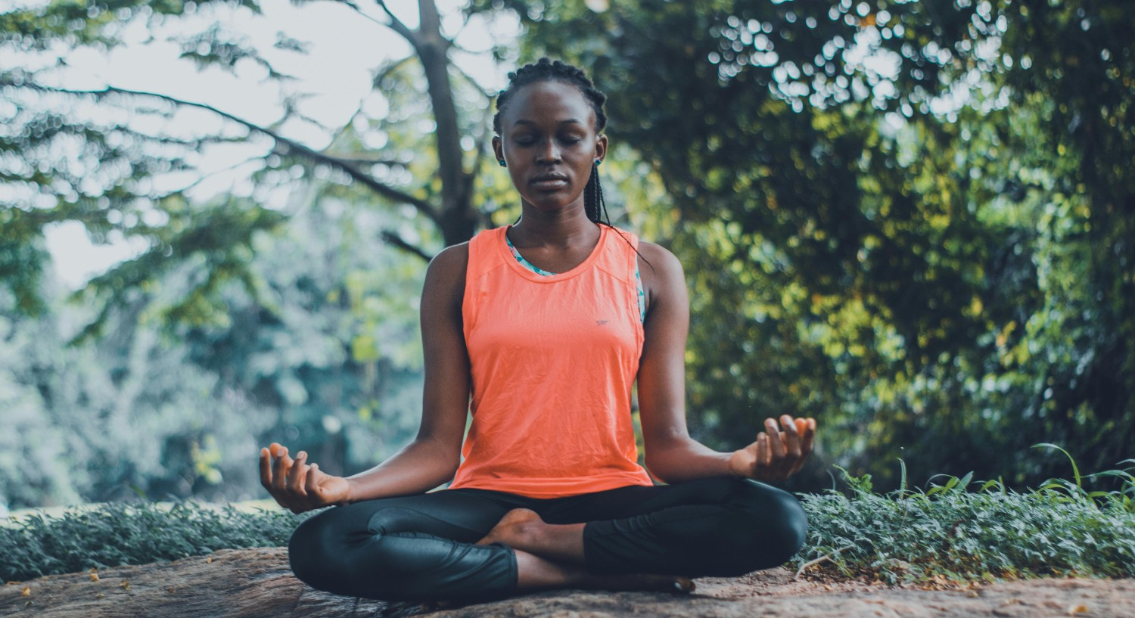**Headaches and migraines.** When you are stressed, your muscles tense up. Long-term tension can lead to headache, migraine, and general body aches and pains. Tension-type headaches are common in women.
* **Depression and anxiety.** In the past year, women were almost twice as likely as men to have symptoms of depression. Women are more likely than men to have an anxiety disorder, including post-traumatic stress disorder, panic disorder, or obsessive-compulsive disorder. Research suggests that women may feel the symptoms of stress more or get more of the symptoms of stress than men. This can raise their risk of depression and anxiety.
* **Heart problems.** High stress levels can raise your blood pressure and heart rate. Over time, high blood pressure can cause serious health problems, such as stroke and heart attacks. Younger women with a history of heart problems especially may be at risk of the negative effects of stress on the heart. Learn more about stress and heart disease.
* 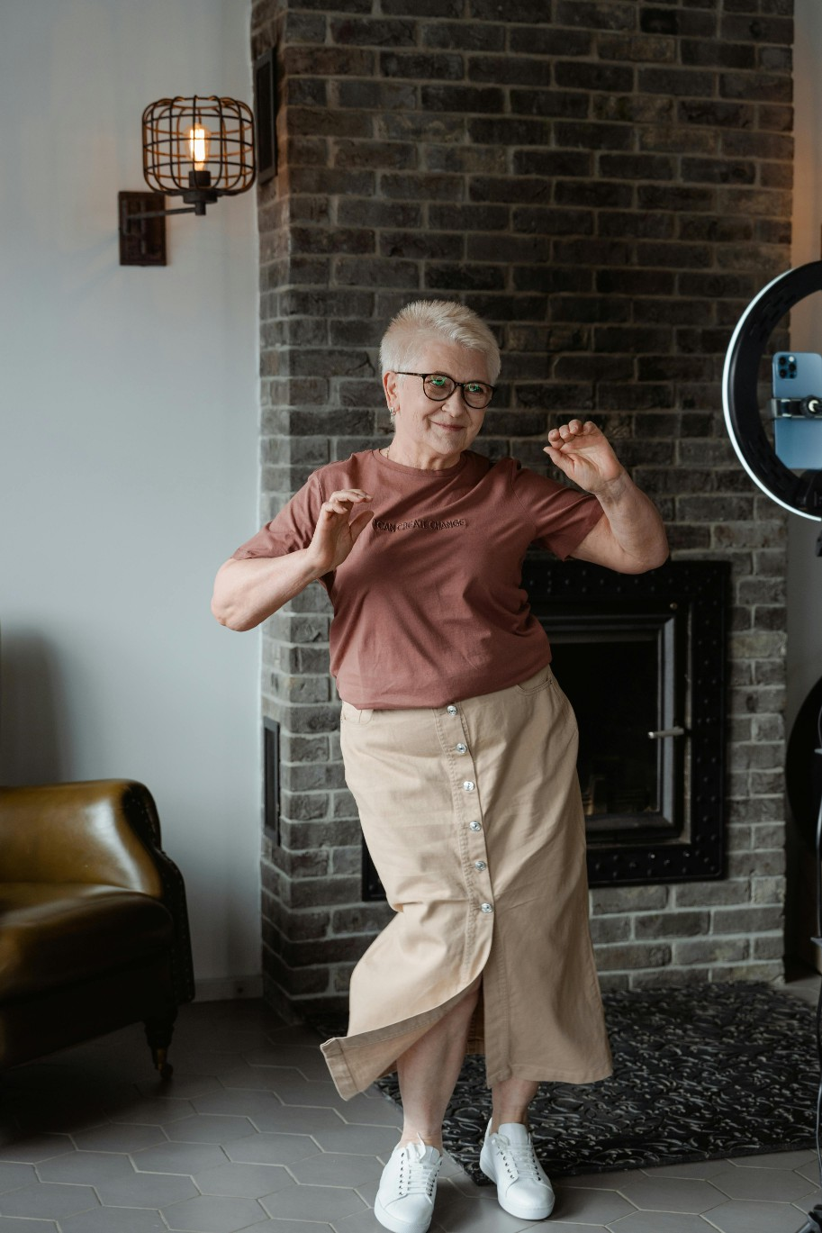**Upset stomach.** Short-term stress can cause stomach issues such as diarrhea or vomiting. Long-term stress can lead to irritable bowel syndrome (IBS), a condition that is twice as common in women as in men. Stress can make IBS symptoms such as gas and bloating worse.
  + **Obesity.** The link between stress and weight gain is stronger for women than for men. Stress increases the amount of a hormone in your body called cortisol, which can lead to overeating and cause your body to store fat.
  + **Problems getting pregnant.** Women with higher levels of stress are more likely to have problems getting pregnant than women with lower levels of stress. Also, not being able to get pregnant when you want to can be a source of stress.
  + **Menstrual cycle problems.** Women who experience chronic or long-term stress may have more severe premenstrual syndrome (PMS) symptoms or irregular periods. Some studies link past abuse or trauma to more severe PMS.

PAGE 1

HELPING HANDS JULY 2024

Everyone has to deal with stress at some point in their lives. You can take steps to help handle stress in a positive way.

* **Take deep breaths.** This forces you to breathe slower and helps your muscles relax. The extra oxygen sends a message to your brain to calm and relax the body.
* **Stretch.** Stretching can also help relax your muscles and make you feel less tense.
* **Write out your thoughts.** Keeping a journal or simply writing down the things you are thankful for can help you handle stress.
* **Take time for yourself.** It could be listening to music, reading a good book, or going to a movie.
* **Get enough sleep.** Most adults need 7 to 9 hours of sleep a night to feel rested.
* **Eat right.**, eat foods with B vitamins, such as bananas, fish, avocados, chicken, and dark green, leafy vegetables. B vitamins can help relieve stress by regulating nerves and brain cells.25
* **Get moving.** Physical activity can relax your muscles and improve your mood. Physical activity also may help relieve symptoms of depression and anxiety.26 Physical activity boosts the levels of “feel-good” chemicals in your body called endorphins. Endorphins can help improve your mood.
* **Try not to deal with stress in unhealthy ways.** This includes drinking too much alcohol, using drugs, smoking, or overeating. These coping mechanisms may help you feel better in the moment but can add to your stress levels in the long term. Try substituting healthier ways to cope, such as spending time with friends and family, exercising, or finding a new hobby.
* **Get help from a professional if you need it.** Your doctor or nurse may suggest counseling or prescribe medicines, such as antidepressants or sleep aids. You can also find a therapist in your area using the mental health services locator on the top left side (desktop view) or bottom (mobile view) of this page. If important relationships with family or friends are a source of stress, a counselor can help you learn new emotional and relationship skills.

The heart and soul of the District 141 Em- ployee Assistance Program is the local lodge EAP peer coordinator. These dedicated men and women volunteer their personal time to

Chronic or long-term stress affects women include:

* Pain, including back pain
* Acne and other skin prob- lems, like rashes or hives
* Headaches
* Upset stomach
* Feeling like you have no control
* Forgetfulness
* Lack of energy
* Lack of focus
* Overeating or not eating enough
* Being easily angered
* Trouble sleeping
* Drug and alcohol misuse
* Loss of interest in things you once enjoyed
* Less interest in sex than usual

assist union members and their families who are experiencing personal difficulties. EAP peers do not make clinical diagno- ses or clinical evaluations; however, they are trained to get an idea of your situation and refer you to an appropriate resource for a more detailed evaluation. EAP peers will follow up to en- sure you have been able to access services that address the difficulty you were experiencing.

IAM EAP

Midwest Region Representative:

Kris Treder (708)-552-6454

E-Mail: [ktreder@iam141.org](mailto:ktreder@iam141.org)

PAGE 2