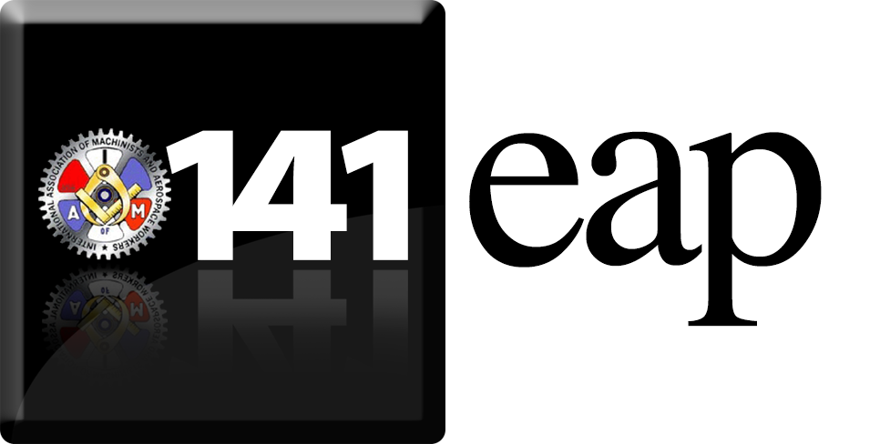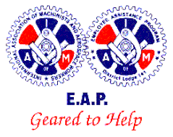

Call For Employee Assistance Program
Peer Coordinators

The International Association of Machinist’s Employee Assistance Program help to address difficulties that our members may be experiencing. Peer coordinators are an important part of this process. Peer coordinators function as part of an EAP team, along with the IAM Regional Coordinator.

Duties include:

- Advocates for the use of the Employee Assistance Program by providing information to employees, their families, supervisors, and union representatives as requested.
- Protects the confidentiality of the member to the fullest extent permitted by law.
- Provides support and encourages the member to accept and follow through on Employee Assistance Program recommendations.
- May assist in the evaluation of referral resources through interviews, surveys of treatment providers, and site visits to ensure a high quality of care for union members.
- Participates in EAP training and may assist in the training of other members in EAP issues.
- Supports the member in the return to work process.

If you are interested please contact:

IAM Central Region Employee Assistance Program
Regional Representative
Marvin Harris
(708) 552-6454
E-Mail: iameapmarvin@gmail.com

or
Bryan Hutchinson, Director, IAM EAP Services, District 141
Cell: 303-229-5117, E-mail: bryanrhutch@aol.com

